**UNIT-I**

**Chapter-1 (Introduction)**

**What is the Internet of Things**

**Different Definitions of IoT**IoT stands for Internet of Things. It refers to the interconnectedness of physical devices, such as appliances and vehicles, that are embedded with software, sensors, and connectivity which enables these objects to connect and exchange data. This technology allows for the collection and sharing of data from a vast network of devices, creating opportunities for more efficient and automated systems.

3. The Internet of Things (IoT) is a computing concept that describes the idea of everyday physical objects being connected to the internet and being able to identify themselves to other devices and send and receive data.

4. The Internet of Things, also called The Internet of Objects, refers to wireless network between objects, usually the network

will be wireless and self-configuring, such as household appliances. (Wikipedia).

5. The term "Internet of Things” has come to describe a number of technologies and research disciplines that enable the Internet to reach out into the real world of physical objects. (IoT 2008).

6. The Internet of Things (IoT) refers to a vast number of "things" that are connected to the internet so they can share data with other things — IoT applications, connected devices, industrial machines and more. Internet-connected devices use built-in sensors to collect data and, in some cases, act on it. IoT connected devices and machines can improve how we work and live. Real-world Internet of Things examples range from a smart home that automatically adjusts heating and lighting to a smart factory that monitors industrial machines to look for problems, then automatically adjusts to avoid failures.(2020)

**2. The internet of things (IoT) is a set of technologies that uses sensors and actuators to inform us about the status of everyday items such as vehicles, tools and even living beings. It allows us to interact with them, enabling connectivity with platforms in the cloud that receive and process information for posterior analysis. This analyzed data is then used to make decisions.**

**Internet of Things (IoT)** is the networking of physical objects that contain electronics embedded within their architecture in order to communicate and sense interactions amongst each other or with respect to the external environment. In the upcoming years, IoT-based technology will offer advanced levels of services and practically change the way people lead their daily lives. Advancements in medicine, power, gene therapies, agriculture, smart cities, and smart homes are just a very few of the categorical examples where IoT is strongly established.

***IoT is network of interconnected computing devices which are embedded in everyday objects, enabling them to send and receive data.***

**Components of IOT**

* **Low-power embedded systems:**Less battery consumption, high performance are the inverse factors that play a significant role during the design of electronic systems.
* **Sensors :**Sensors are the major part of any IoT applications. It is a physical device that measures and detect certain physical quantity and convert it into   signal which can be provide as an input to processing or control unit for analysis purpose.

1. Different types of Sensors :
2. Temperature Sensors
3. Image Sensors
4. Gyro Sensors
5. Obstacle Sensors
6. RF Sensor
7. IR Sensor
8. MQ-02/05 Gas Sensor
9. LDR Sensor
10. Ultrasonic Distance Sensor

* **Control Units :** It is a unit of small computer on a single integrated circuit containing microprocessor or processing core, memory and programmable input/output devices/peripherals. It is responsible for major processing work of IoT devices and all logical operations are carried out here.
* **Cloud computing:**Data collected through IoT devices is massive and this data has to be stored on a reliable storage server. This is where cloud computing comes into play. The data is processed and learned, giving more room for us to discover where things like electrical faults/errors are within the system.
* **Availability of big data:**We know that IoT relies heavily on sensors, especially in real-time. As these electronic devices spread throughout every field, their usage is going to trigger a massive flux of big data.
* **Networking connection:**In order to communicate, internet connectivity is a must where each physical object is represented by an IP address. However, there are only a limited number of addresses available according to the IP naming. Due to the growing number of devices, this naming system will not be feasible anymore. Therefore, researchers are looking for another alternative naming system to represent each physical object.

**There are two ways of building IoT:**

1. Form a separate internetwork including only physical objects.
2. Make the Internet ever more expansive, but this requires hard-core technologies such as rigorous cloud computing and rapid big data storage (expensive).

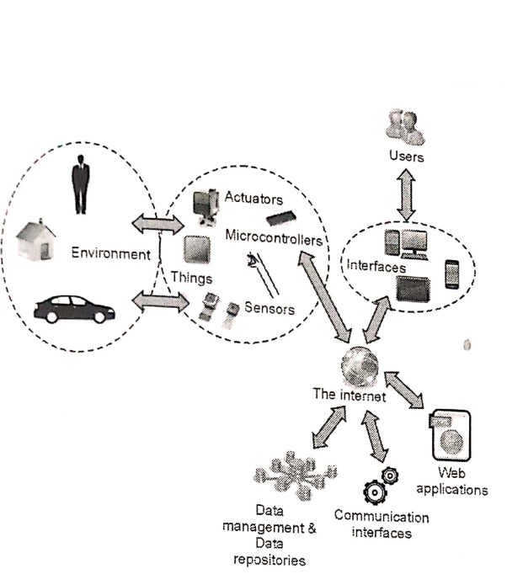

Working with IOT

Internet of Things Applications

The **Internet of Things (IoT)** provides the ability to interconnect computing devices, mechanical machines, objects, animals or unique identifiers and people to transfer data across a network without the need for human-to-human or human-to-computer is a system of conversation. **IoT applications** bring a lot of value in our lives. The Internet of Things provides objects, **computing devices**, or **unique identifiers** and people's ability to transfer data across a network without the **human-to-human** or **human-to-computer interaction**

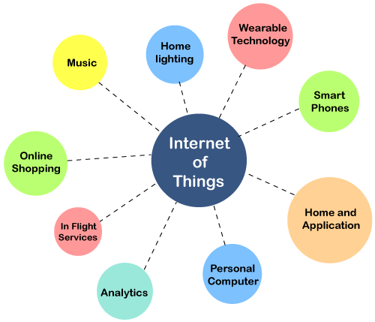

A traffic camera is an intelligent device. The camera monitors **traffic congestion, accidents** and **weather conditions** and can access it to a common entrance.

This gateway receives data from such cameras and transmits information to the city's **traffic monitoring system**.

For example, the municipal corporation has decided to repair a road that is connected to the national highway. It may cause traffic congestion to the national highway. The insight is sent to the traffic monitoring system.

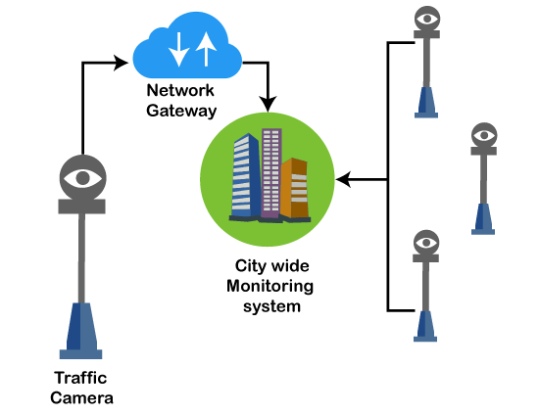

The intelligent system analyzes the situation, estimate their impact, and relay information to other cities connected to the same highway. It generates live instructions to drivers by smart devices and radio channels

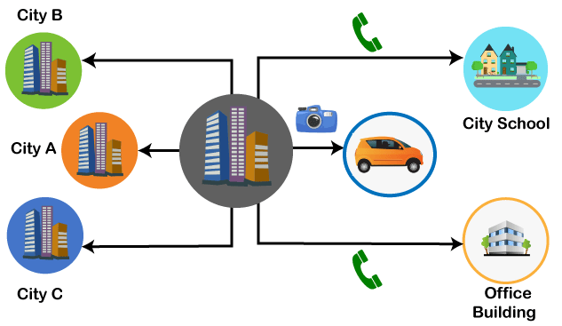

## **Applications of IoT**

### **1. Wearables**

Wearable technology is the hallmark of IoT applications and one of the earliest industries to deploy IoT. We have fit bits, heart rate monitors and smartwatches these days.

Guardian glucose monitoring device has been developed to help people with diabetes. It detects glucose levels in our body, uses a small electrode called the glucose sensor under the skin, and relates it to a radiofrequency monitoring device.

### **2. Smart Home Applications**

The smart home is probably the first thing when we talk about the IoT application. The example we see the AI home automation is employed by **Mark Zuckerberg. Alan Pan's** home automation system, where a string of musical notes uses in-house functions.

### **3. Health care**

IoT applications can transform reactive medical-based systems into active wellness-based systems. Resources that are used in current medical research lack important real-world information. It uses controlled environments, leftover data, and volunteers for clinical trials. The **Internet of Things** improves the device's **power, precision** and **availability**. IoT focuses on building systems rather than just tools. Here's how the IoT-enabled care device works.

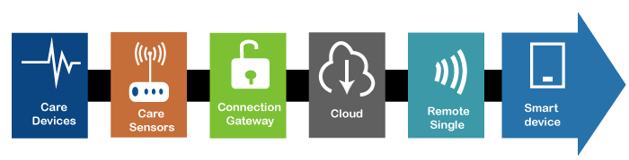

### **4. Smart Cities**

Most of you have heard about the term smart city. Smart city uses technology to provide services. The smart city includes improving transportation and social services, promoting stability and giving voice to their citizens.

### **5. Agriculture**

By the year **2050**, the world's growing population is estimated to have reached about 10 billion. To feed such a large population, agriculture needs to marry technology and get the best results. There are many possibilities in this area. One of them is Smart Greenhouse.

Farming techniques grow crops by **environmental parameters**. However, manual handling results in production losses, energy losses and labor costs, making it less effective.

The greenhouse makes it easy to monitor and enables to control the climate inside it.

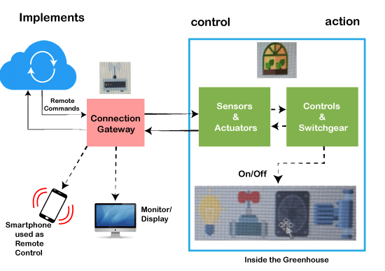

### **6. Industrial Automation**

It is one of the areas where the quality of products is an essential factor for a more significant investment return. Anyone can **re-engineer** products and their packaging to provide superior performance in **cost** and **customer experience** with IoT applications. IoT will prove as a game-changer. In industrial automation, IoT is used in the following areas:

* **Product flow monitoring**
* **Factory digitization**
* **Inventory management**
* **Safety and security**
* **Logistics and Supply Chain Optimization**
* **Quality control**
* **Packaging customization**

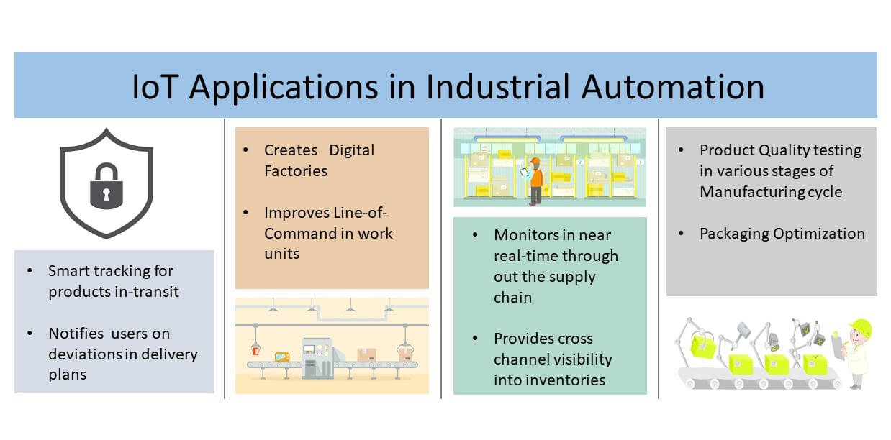

### **7. Hacked Car**

A connected car is a technology-driven car with Internet access and a WAN network. The technology offers the user some benefits such as in-car infotainment, advanced navigation and fuel efficiency.

### **8. Healthcare**

Healthcare do real-time monitoring with the help of smart devices. It gathers and transfers health data such as blood pressure, blood sugar levels, weight, oxygen, and ECG. The patient can contact the doctor by the smart mobile application in case of any emergency.

### **9. Smart Retail**

IoT applications in retail give shoppers a new experience. Customers do not have to stand in long queues as the checkout system can read the tags of the products and deduct the total amount from the customer's payment app with IoT applications' help.

### **10. Smart Supply Chain**

Customers automate the delivery and shipping with a smart supply chain. It also provides details of real-time conditions and supply networks.

### **11. Smart Farming**

Farmers can minimize waste and increase productivity. The system allows the monitoring of fields with the help of sensors. Farmers can monitor the status of the area.

Internet-connected devices go from 5 million to billions in just one year. Business Insider Intelligence estimates 24 billion IoT devices will install and generate more than 300 billion in revenue in the future.

**Similar Concepts of IOT**

Other than the IoT we mentioned above. There is another similar concept called IIoT, which stands for the Industrial Internet of Things. Both of them have some similarities like the character of availability, intelligent and connected devices. The only difference between those two is their general usages. While IoT is most commonly used for consumer usage. IIoT is used for industrial purposes such as manufacturing, supply chain monitor, and management system. This illustration below will give you a clearer picture of both concepts.

IoT devices are more used in household purposes and are not completely automated. They are more on the general usage side whereas IIoT is more on the professional side. It is mostly used for high-end applications and is mostly fully automated and can work in extreme conditions.

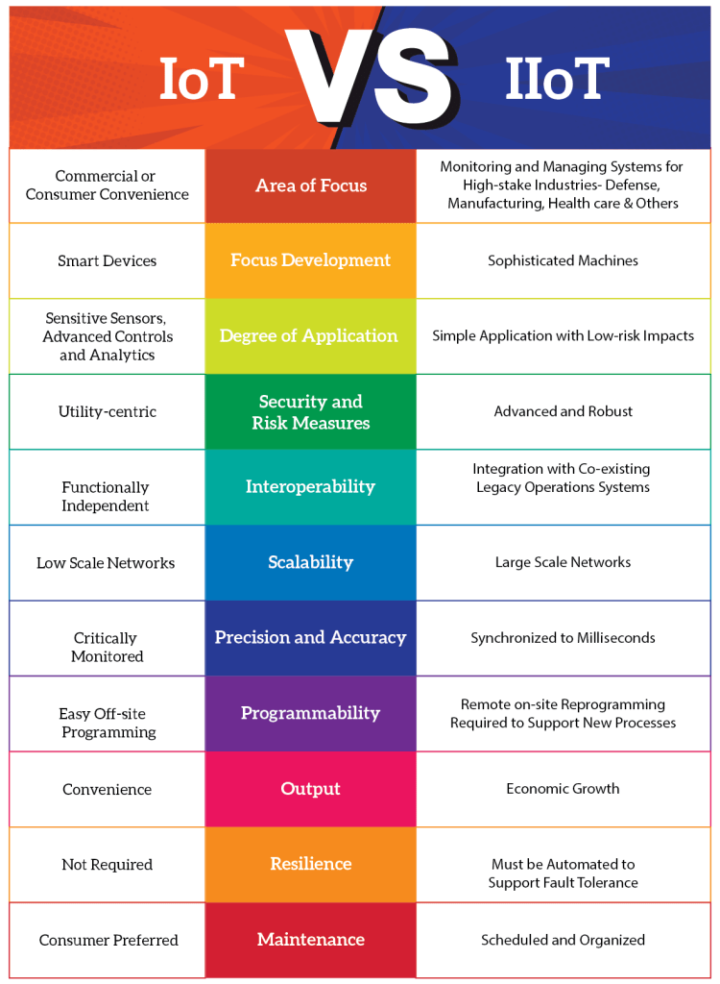

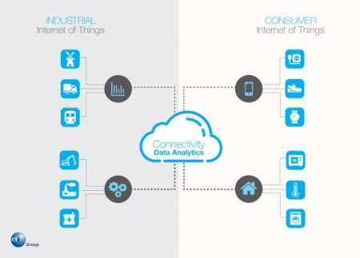

## **Sensors**

A better term for a sensor is a transducer. A transducer is any physical device that converts one form of energy into another. So, in the case of a sensor, the transducer converts some physical phenomenon into an electrical impulse that determines the reading. A microphone is a sensor that takes vibrational energy (sound waves), and converts it to electrical energy in a useful way for other components in the system to correlate back to the original sound.

## **Actuators**

Another type of transducer that you will encounter in many [IoT systems](https://bridgera.com/iot-systems-overview/) is an actuator. In simple terms, an actuator operates in the reverse direction of a sensor. It takes an electrical input and turns it into physical action. For instance, an electric motor, a hydraulic system, and a pneumatic system are all different types of actuators.

## **Controller**

In a typical IoT system, a sensor may collect information and route to a control center. There, previously defined logic dictates the decision. As a result, a corresponding command controls an actuator in response to that sensed input. Thus, sensors and actuators in IoT work together from opposite ends. Later, we will discuss where the control center resides in the greater IoT system.

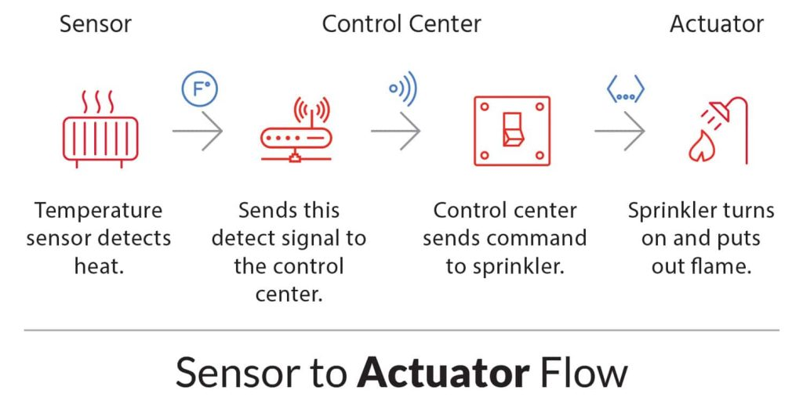

What are Smarts Objects in IoT

The concept of smart in IoT is used for physical objects that are active, digital, networked, can operate to some extent autonomously, reconfigurable and has local control of the resources. The smart objects need energy, data storage, etc.

A **smart object** is an object that enhances the interaction with other smart objects as well as with people also. The world of IoT is the network of interconnected heterogeneous objects (such as smart devices, smart objects, sensors, actuators, RFID, embedded computers, etc.) uniquely addressable and based on standard communication protocols.

In a day to day life, people have a lot of object with internet or wireless or wired connection. Such as:

* Smartphone
* Tablets
* TV computer

These objects can be interconnected among them and facilitate our daily life (smart home, smart cities) no matter the situation, localization, accessibility to a sensor, size, scenario or the risk of danger

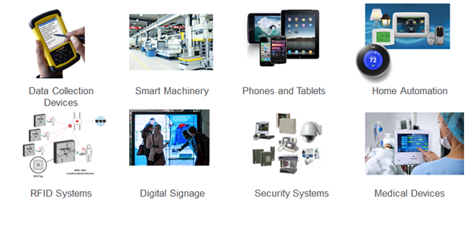

Smart objects are utilized widely to transform the physical environment around us to a digital world using the Internet of things (IoT) technologies.

A smart object carries blocks of application logic that make sense for their local situation and interact with human users. A smart object sense, log, and interpret the occurrence within themselves and the environment, and intercommunicate with each other and exchange information with people.

The work of smart object has focused on technical aspects (such as software infrastructure, hardware platforms, etc.) and application scenarios. Application areas range from supply-chain management and enterprise applications (home and hospital) to healthcare and industrial workplace support. As for human interface aspects of smart-object technologies are just beginning to receive attention from the environment.

**Smart applications.**

Smart Apps are innovative systems that gather tremendous amounts of data from sensors and other sources, using machine learning algorithms and predictive analytics to make this information actionable for users and to improve experiences. Unlike their predecessors they are:

1. Intelligent – Smart Apps use analytics, machine learning and AI services to make recommendations and predictions that guide users and things to take the next best action.
2. Contextual – Using personal, sensor and location data, Smart Apps are personalized, embedded in users’ processes and available on any channel/device.
3. 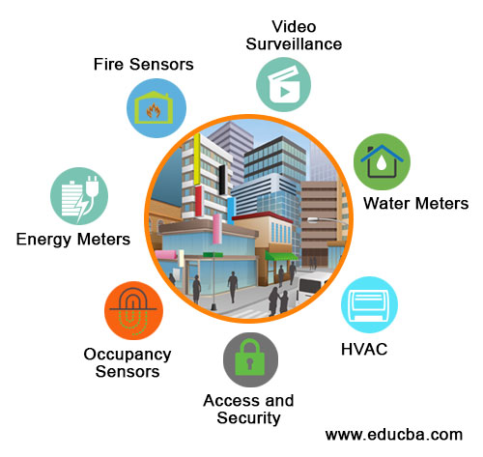
4. Proactive – Smart Apps come to the user versus the other way around, leveraging push notifications, chat bots and messaging services to proactively interact with users and give them smart recommendations of what to do and when.

**IoT − Advantages**

1. Improved Customer Engagement − Current analytics suffer from blind-spots and significant flaws in accuracy; and as noted, engagement remains passive. IoT completely transforms this to achieve richer and more effective engagement with audiences.
2. Technology Optimization − The same technologies and data which improve the customer experience also improve device use, and aid in more potent improvements to technology. IoT unlocks a world of critical functional and field data.
3. Reduced Waste − IoT makes areas of improvement clear. Current analytics give us superficial insight, but IoT provides real-world information leading to more effective management of resources.
4. Enhanced Data Collection − Modern data collection suffers from its limitations and its design for passive use. IoT breaks it out of those spaces, and places it exactly where humans really want to go to analyze our world. It allows an accurate picture of everything.

**IoT − Disadvantages**

1. Security − IoT creates an ecosystem of constantly connected devices communicating over networks. The system offers little control despite any security measures. This leaves users exposed to various kinds of attackers.
2. Privacy − The sophistication of IoT provides substantial personal data in extreme detail without the user's active participation.
3. Complexity − Some find IoT systems complicated in terms of design, deployment, and maintenance given their use of multiple technologies and a large set of new enabling technologies.
4. Flexibility − Many are concerned about the flexibility of an IoT system to integrate easily with another. They worry about finding themselves with several conflicting or locked systems.
5. Compliance − IoT, like any other technology in the realm of business, must comply with regulations. Its complexity makes the issue of compliance seem incredibly challenging when many consider standard software compliance a battle.